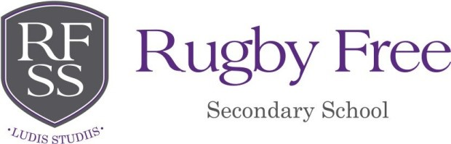
Rugby Free Secondary School: Statement of Values and Ethos 2025-26 Academic Year School Summary:
We are proud to be judged as 'Good' in all areas by Ofsted. This reflects the tireless work that staff, students and parents and carers have undertaken together in recent years. Together, we have established a culture of high expectations across the school, supported every step of the way by our Trust. An ambitious culture has been achieved through the development of strong and positive relationships with all stakeholders. Our reflective approach means we are always striving to improve in all that we do and believe that mistakes are only an opportunity to learn. Students from over 35 primary schools join the RFSS family each year from across Warwickshire, all of whom bringing all their own set of experiences from their previous school community. Therefore, we invest heavily in pastoral support to ensure all students can establish positive relationships with their peers and very quickly feel part of the RFSS family. We are proud of our school and our community, and the ways in which we work together to ensure that RFSS is the best school that it can be.
At Rugby Free Secondary School, we are committed to providing a caring, friendly and safe environment for all of our students so they can learn in a positive and secure atmosphere. We believe every student should have the opportunity in all school activities in an enjoyable and safe environment, and be protected from harm. This is the responsibility of every adult employed by, or invited to deliver services at, Rugby Free Secondary School. We recognise our responsibility to safeguard and promote the welfare of all our students by protecting them from physical, sexual or emotional abuse, neglect and bullying, and to expose them to experiences inside and outside of the classroom that support them to achieve the best possible academic outcomes from their relevant starting points. Our core values are:
- Respect
- Collaboration
- Kindness
- Resilience
- Curiosity
- Endeavour
The culture and ethos of our school cannot be felt on a piece of paper. In fact, it is a living and breathing set of features that is underpinned by having relationships at the heart of what we do, and ensuring that there is inclusion for all. All interactions between staff, students and parents/ carers will be characterised by a code of common courtesy and good manners. Partnership, working together and celebrating our diverse cultures, are the cornerstones of our school community.
We are committed to providing a service to our students that is respectful and kind, whilst staff will demonstrate due consideration and respect for their students. Students' rights to voice opinions will be recognised and staff will work with students to deal with their concerns. The efforts which members of staff make to improve the learning process and promote partnership will be recognised by students adopting an active role in their own learning.
When dealing with difficult situations we will seek to resolve problems by restoration, respecting the feelings of all involved. The school will continue to develop its existing positive links with the local community and promote civic pride in its achievements and reputation.

